|  |  |  |
| --- | --- | --- |
| **Promotional Email Creative Brief** | | |
| Campaign Name | 2013Q2BuyBack | |
| Campaign Owner | Helen Park | |
| Contact Information | helen@chegg.com | |
| Due Date of Final Assets | 5/16/2013 ; 5/24/2013 | |
| Live Date | 5/19/2013, 5/26/2013 | |
| **Project Scope** | | |
| Please see below. | | |
| Total Plaintext Files: 4 | | |
| Total HTML Files: 4 | | |
| Total # of Creative Deliverables: 4 | | |
| **Email Components Required** | | **Template:** |
| Hyperlinked Lead in text about branding  Copywriting: Subject Lines  Copywriting: Snippets  Copywriting: Body Copy  Unsubscribe link  Descriptive Alt Tags  View in browser  View on Mobile/Simple Text  Coupons | | Use current template (based on Gen Chegg)  Create new template |
| **If create new template, provide description below:** |
|  |
| **Primary Call to Action** | | **Secondary Call to Action** |
| Get a Quote | |  |
| **Personalization Fields Available** | | |
| We can use first name. Currently, the suggested copy does not use any personalization. | | |
| **Coupon/Offer Terms and Conditions** | | |
| NA | | |

We need 2 versions for the first send. One generic and one targeted.

The targeted version will be sent to users that have searched for one of books that Chegg would like to acquire but did not rent the book from us. The book image, title and isbn and will dynamic.

Due to tight turn around time, we will go with option 3 and add the dynamic piece below.

This mailing will also have a reminder a week later on 5/26.

Ideas:

1. Ease of using Chegg BuyBack

Nice example of how to display this information:

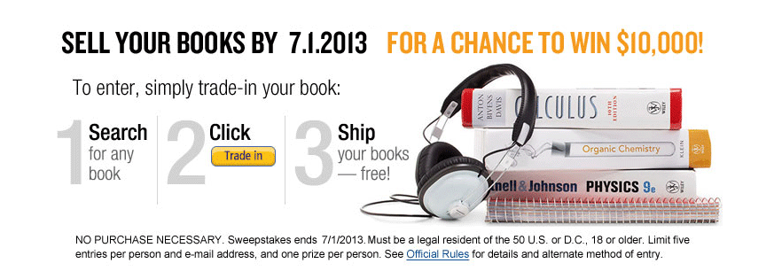

How can we show this message without giving all the information away so that they click on the CTA to take action and learn more?

1. Benefits over competitors (ie. "We pay top dollars" and then in the disclaimer specify how. If we want to be super aggressive, we can say "We pay more than Amazon" and then in the disclaimer specify on average we pay 7% - 15% higher on average based on xyz.") On average, we are about ~53% higher than our partners across the 2,500 titles which we have interest in. Mind you, most if not all of these partners have some kind of independent buyback program (outside of partnering with Chegg). The key competitor that students really care about, however, is Amazon.com. We scrape their buyback pricing daily and, in general, we’re 7%-15% higher. (I’m currently asking Rob Chestnut to see how aggressive we can be with the messaging.)
2. Use old template and swap out image and update copy. Please see the creative below. I am not a huge fan of the image used below. Can we find an image that can be on brand that conveys the message?

Copy

Subject line (ideas):

* Want money for your used textbooks?
* Make money with your used textbooks

Headline: Get the most money out of your used textbooks!

Body: Making money couldn’t be any easier. No lines, no hassles, plus get free shipping. Simply click the button below to get started.

CTA button: Get a Quote

Last Buy Back creative: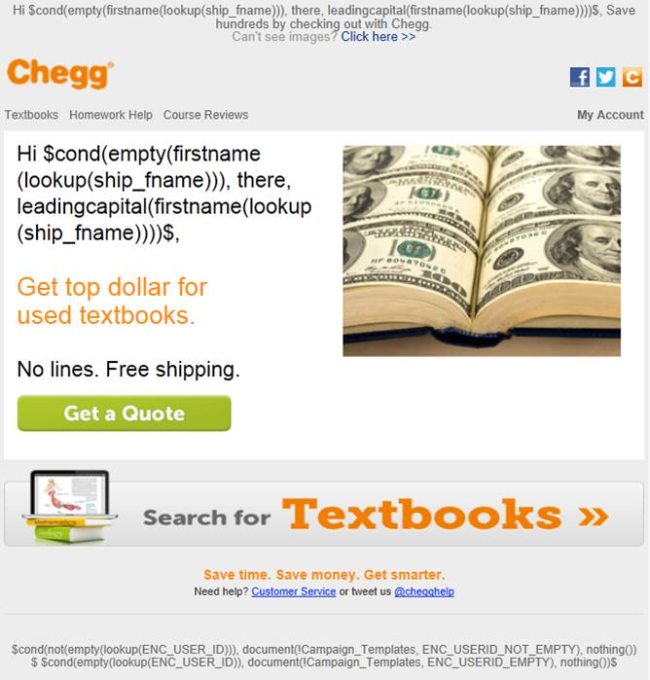

Targeted textbooks (dynamic piece):

Headline: Own this book? You can make top dollars.

Show image of book, book title and ISBN.

CTA: Click here to find out how much you can make >>

Very rough, but this is the placement of the dynamic piece.

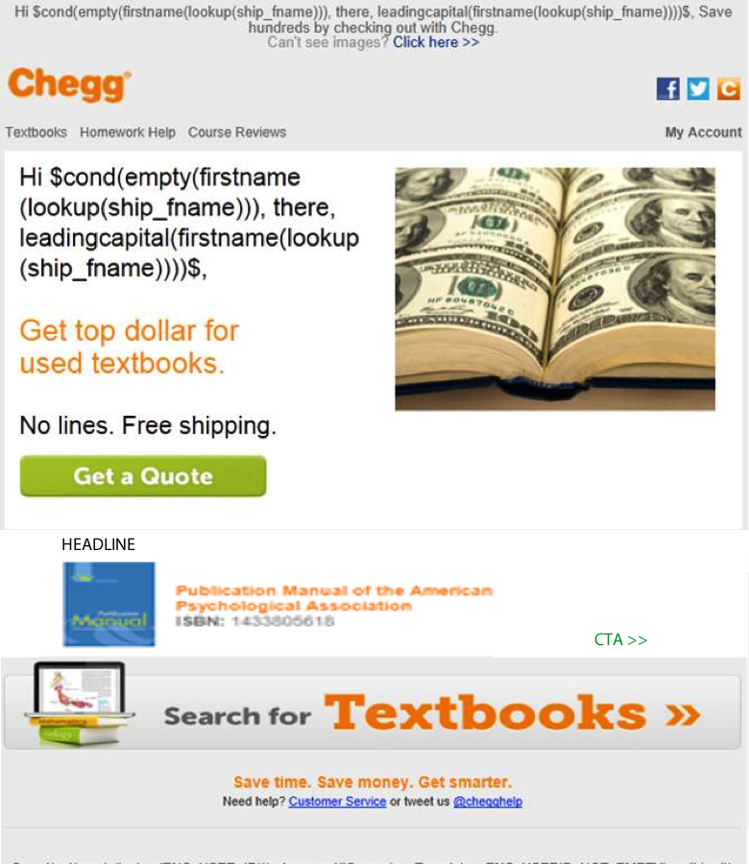

**Reminder Email**

We will use the same template as the prior mailing. Is there another image we should use, or should we use what was sent on 5/19?

Copy

Subject line (ideas):

* Don’t forget to sell your used textbooks

Headline: It’s not too late! Make money with your used textbooks.

Body: Making money couldn’t be any easier. No lines, no hassles, plus get free shipping. Simply click the button below to get started.

CTA button: Get a Quote